**Music Data Analysis**

The entire directory structure has been moved to /home/acadgild

**All the scripts are given 774 permissions:**

chmod 774 /home/acadgild/project/scripts/*

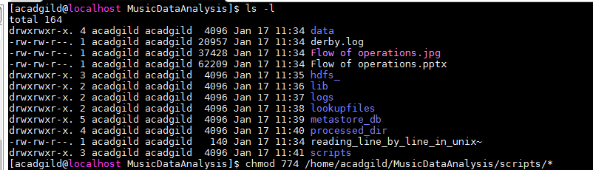

**Scripts:**

--------

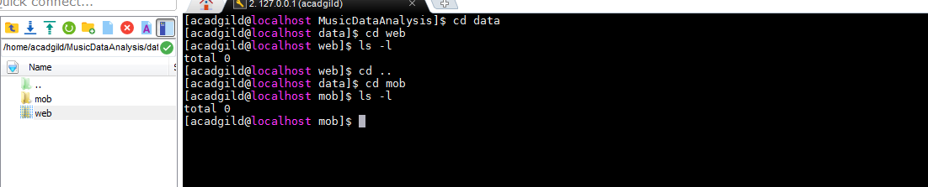

**generate_web_data.py -- Generates some random data coming from web application**

python /home/acadgild/MusicDataAnalysis/scripts/generate_web_data.py

**generate_mob_data.py -- Generates some random data coming from mobile application**

python /home/acadgild/ MusicDataAnalysis /scripts/generate_mob_data.py

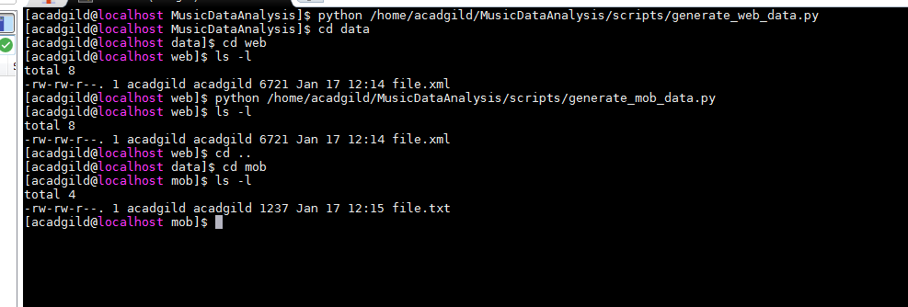

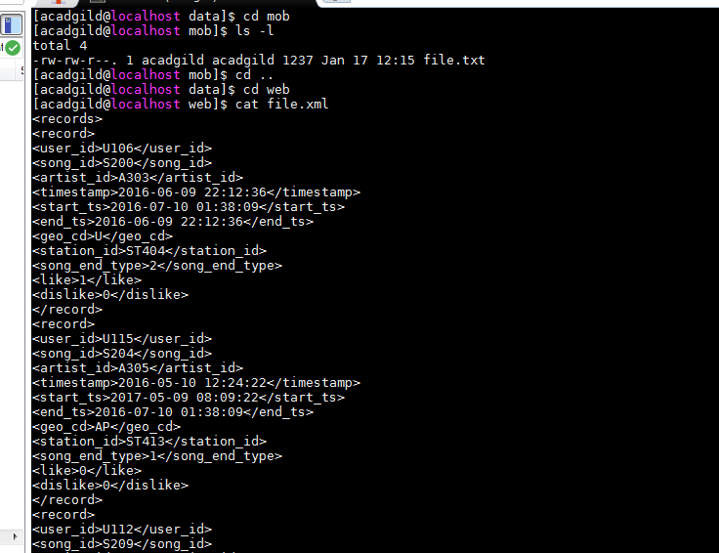

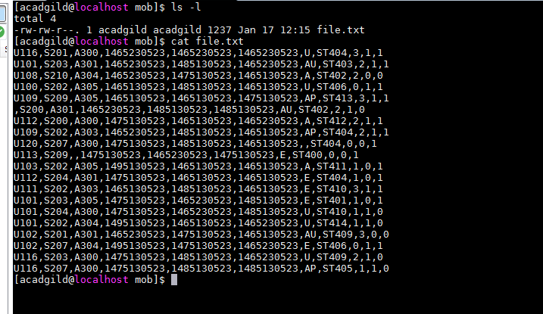

**start-daemons.sh -- Launches all necessary daemons**

sh /home/acadgild/MusicDataAnalysis/scripts/start-daemons.sh

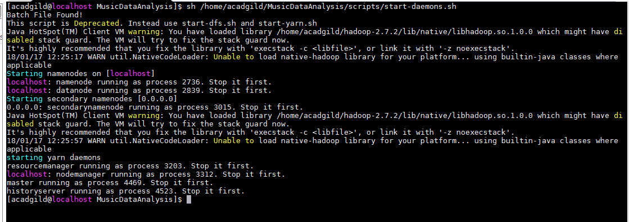

**populate-lookup.sh -- Populates lookup tables**

sh /home/acadgild/ MusicDataAnalysis /scripts/populate-lookup.sh

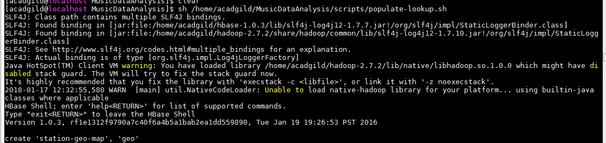

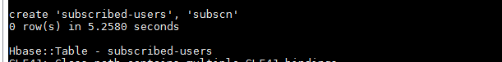

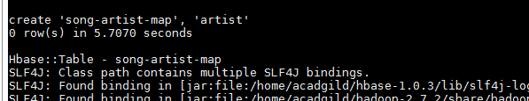

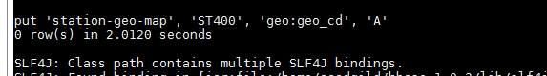

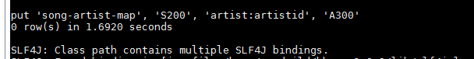

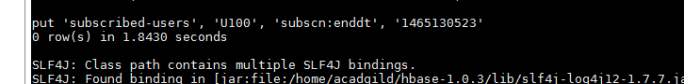

**dataformatting.sh -- Performs data formatting**

sh /home/acadgild/ MusicDataAnalysis /scripts/dataformatting.sh



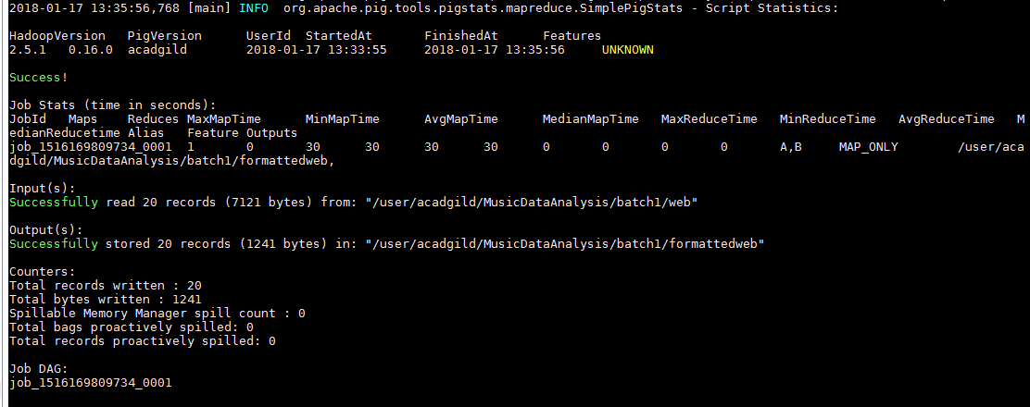

hive -f /home/acadgild/ MusicDataAnalysis /scripts/create_hive_hbase_lookup.hql

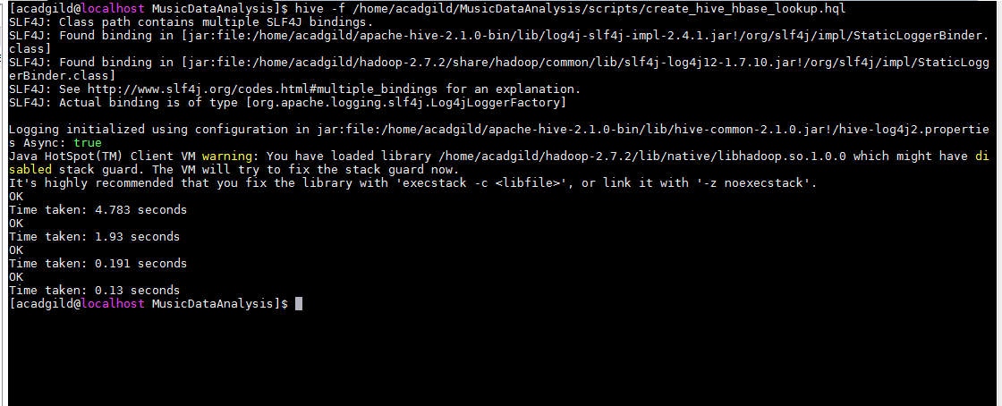

**data_enrichment.sh -- Performs data enrichment and cleaning**

sh /home/acadgild/MusicDataAnalysis/scripts/data_enrichment.sh

**data_analysis.sh -- Performs data analysis**

--sh /home/acadgild/ MusicDataAnalysis /scripts/data_analysis.sh

**Determine top 10 station_id(s) where maximum number of songs were played, which were**

**liked by unique users.**

SET hive.auto.convert.join=false;

USE project;

SET hive.support.sql11.reserved.keywords=false;

CREATE TABLE IF NOT EXISTS top_10_stations

(

station_id STRING,

total_distinct_songs_played INT,

distinct_user_count INT

)

PARTITIONED BY (batchid INT)

ROW FORMAT DELIMITED

FIELDS TERMINATED BY ','

STORED AS TEXTFILE;

INSERT OVERWRITE TABLE top_10_stations

PARTITION(batchid=1)

SELECT

station_id,

COUNT(DISTINCT song_id) AS total_distinct_songs_played,

COUNT(DISTINCT user_id) AS distinct_user_count

FROM enriched_data

WHERE status='pass'

AND batchid=1

AND like=1

GROUP BY station_id

ORDER BY total_distinct_songs_played DESC

LIMIT 10;

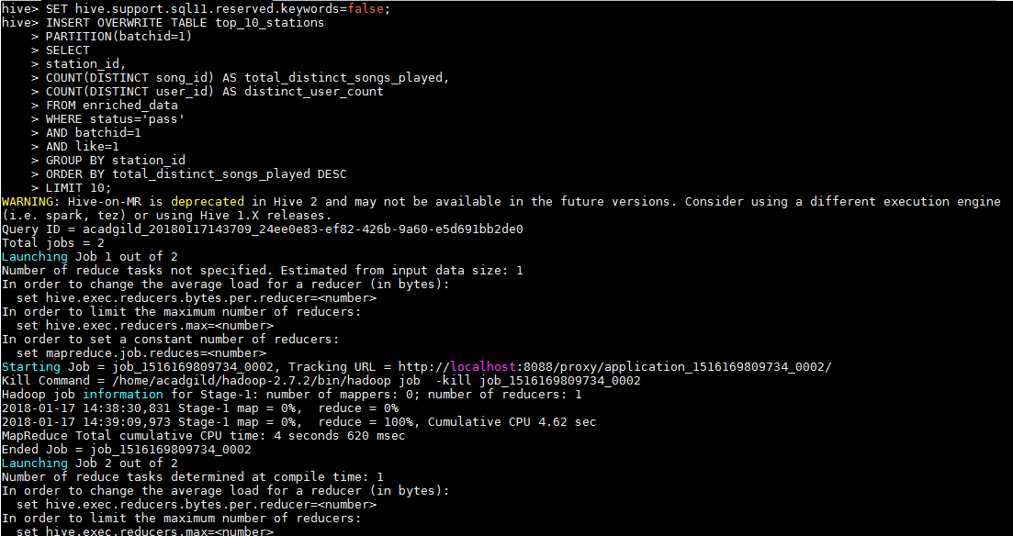

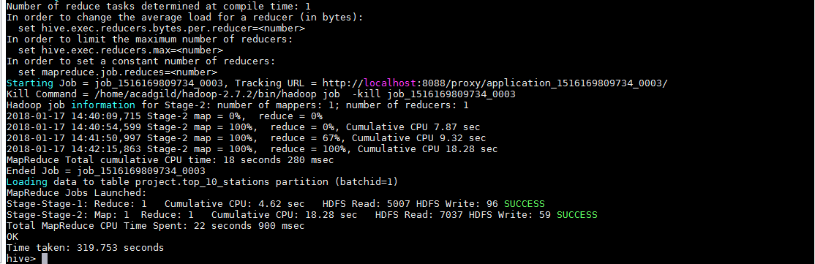

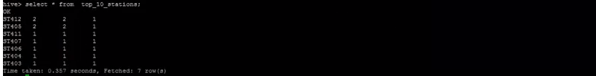

**Determine total duration of songs played by each type of user, where type of user can be**

**'subscribed' or 'unsubscribed'. An unsubscribed user is the one whose record is either not**

**present in Subscribed_users lookup table or has subscription_end_date earlier than the**

**timestamp of the song played by him.**

CREATE TABLE IF NOT EXISTS users_behaviour

(

user_type STRING,

duration INT

)

PARTITIONED BY (batchid INT)

ROW FORMAT DELIMITED

FIELDS TERMINATED BY ','

STORED AS TEXTFILE;

INSERT OVERWRITE TABLE users_behaviour

PARTITION(batchid=1)

SELECT

CASE WHEN (su.user_id IS NULL OR CAST(ed.timestamp AS DECIMAL(20,0)) > CAST(su.subscn_end_dt AS DECIMAL(20,0))) THEN 'UNSUBSCRIBED'

WHEN (su.user_id IS NOT NULL AND CAST(ed.timestamp AS DECIMAL(20,0)) <= CAST(su.subscn_end_dt AS DECIMAL(20,0))) THEN 'SUBSCRIBED'

END AS user_type,

SUM(ABS(CAST(ed.end_ts AS DECIMAL(20,0))-CAST(ed.start_ts AS DECIMAL(20,0)))) AS duration

FROM enriched_data ed

LEFT OUTER JOIN subscribed_users su

ON ed.user_id=su.user_id

WHERE ed.status='pass'

AND ed.batchid=1

GROUP BY CASE WHEN (su.user_id IS NULL OR CAST(ed.timestamp AS DECIMAL(20,0)) > CAST(su.subscn_end_dt AS DECIMAL(20,0))) THEN 'UNSUBSCRIBED'

WHEN (su.user_id IS NOT NULL AND CAST(ed.timestamp AS DECIMAL(20,0)) <= CAST(su.subscn_end_dt AS DECIMAL(20,0))) THEN 'SUBSCRIBED' END;

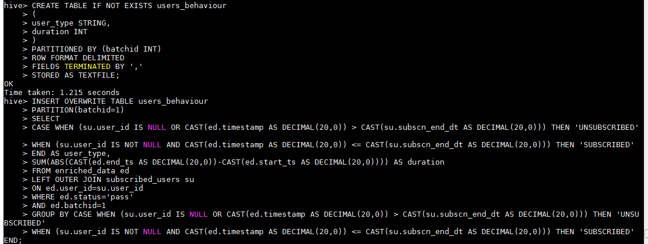

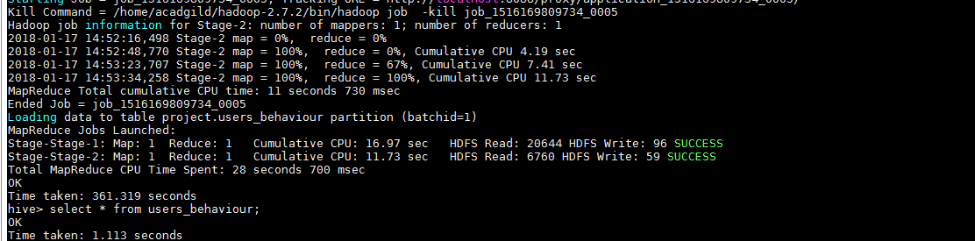

**Determine top 10 connected artists. Connected artists are those whose songs are most**

**listened by the unique users who follow them.**

CREATE TABLE IF NOT EXISTS connected_artists

(

artist_id STRING,

user_count INT

)

PARTITIONED BY (batchid INT)

ROW FORMAT DELIMITED

FIELDS TERMINATED BY ','

STORED AS TEXTFILE;

INSERT OVERWRITE TABLE connected_artists

PARTITION(batchid=1)

SELECT

ua.artist_id,

COUNT(DISTINCT ua.user_id) AS user_count

FROM

(

SELECT user_id, artist_id FROM users_artists

LATERAL VIEW explode(artists_array) artists AS artist_id

) ua

INNER JOIN

(

SELECT artist_id, song_id, user_id

FROM enriched_data

WHERE status='pass'

AND batchid=1

) ed

ON ua.artist_id=ed.artist_id

AND ua.user_id=ed.user_id

GROUP BY ua.artist_id

ORDER BY user_count DESC

LIMIT 10;

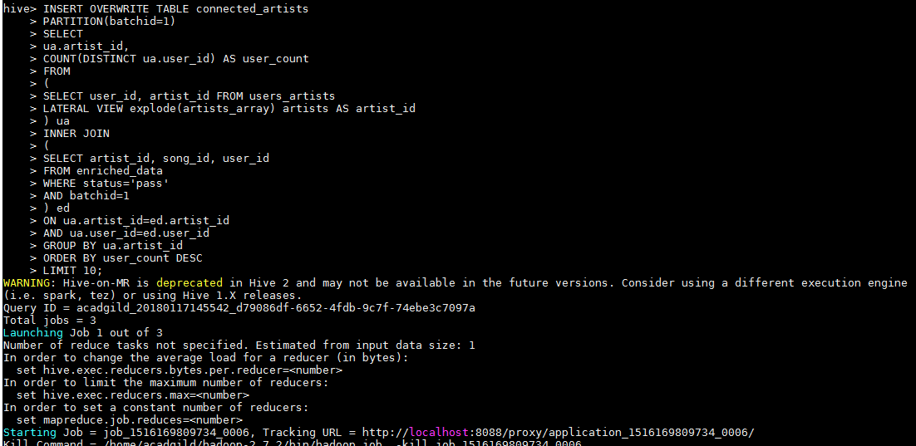

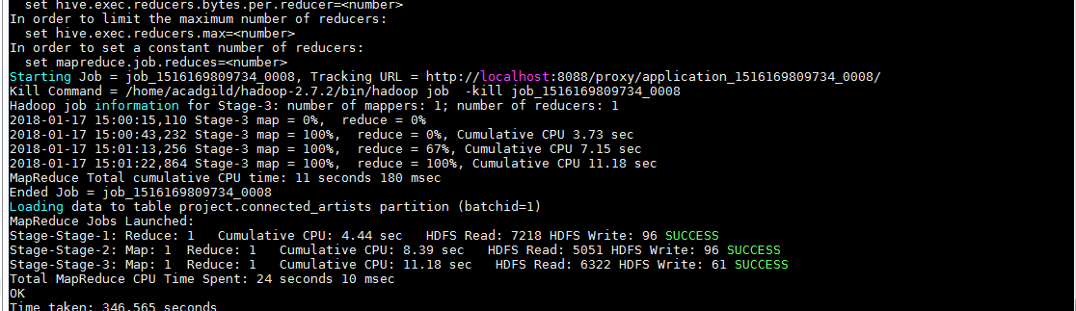

**Determine top 10 songs who have generated the maximum revenue. Royalty applies to a**

**song only if it was liked or was completed successfully or both.**

CREATE TABLE IF NOT EXISTS top_10_royalty_songs

(

song_id STRING,

duration INT

)

PARTITIONED BY (batchid INT)

ROW FORMAT DELIMITED

FIELDS TERMINATED BY ','

STORED AS TEXTFILE;

INSERT OVERWRITE TABLE top_10_royalty_songs

PARTITION(batchid=1)

SELECT song_id,

SUM(ABS(CAST(end_ts AS DECIMAL(20,0))-CAST(start_ts AS DECIMAL(20,0)))) AS duration

FROM enriched_data

WHERE status='pass'

AND batchid=1

AND (like=1 OR song_end_type=0)

GROUP BY song_id

ORDER BY duration DESC

LIMIT 10;

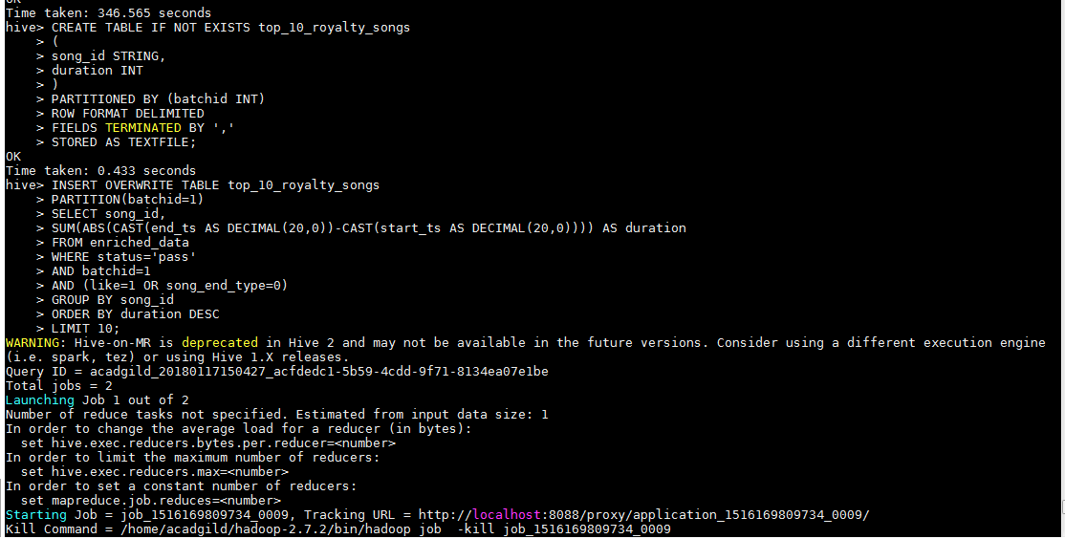

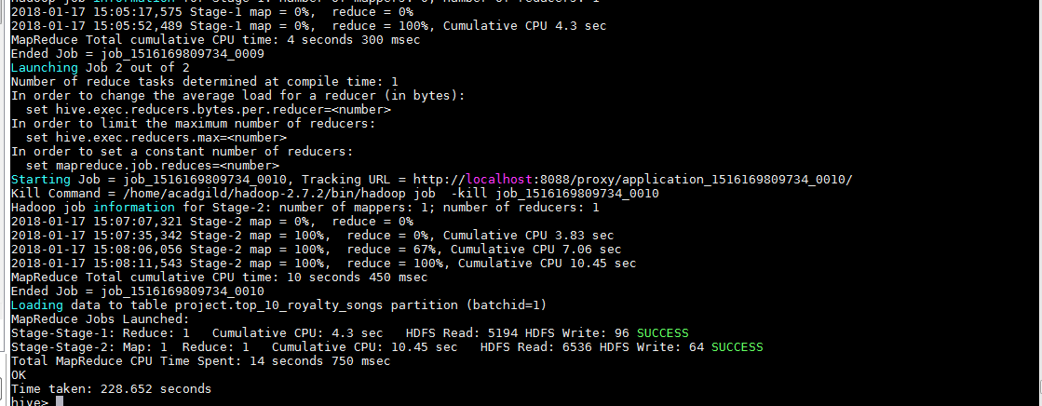

**Determine top 10 unsubscribed users who listened to the songs for the longest duration.**

CREATE TABLE IF NOT EXISTS top_10_unsubscribed_users

(

user_id STRING,

duration INT

)

PARTITIONED BY (batchid INT)

ROW FORMAT DELIMITED

FIELDS TERMINATED BY ','

STORED AS TEXTFILE;

INSERT OVERWRITE TABLE top_10_unsubscribed_users

PARTITION(batchid=1)

SELECT

ed.user_id,

SUM(ABS(CAST(ed.end_ts AS DECIMAL(20,0))-CAST(ed.start_ts AS DECIMAL(20,0)))) AS duration

FROM enriched_data ed

LEFT OUTER JOIN subscribed_users su

ON ed.user_id=su.user_id

WHERE ed.status='pass'

AND ed.batchid=1

AND (su.user_id IS NULL OR (CAST(ed.timestamp AS DECIMAL(20,0)) > CAST(su.subscn_end_dt AS DECIMAL(20,0))))

GROUP BY ed.user_id

ORDER BY duration DESC

LIMIT 10;

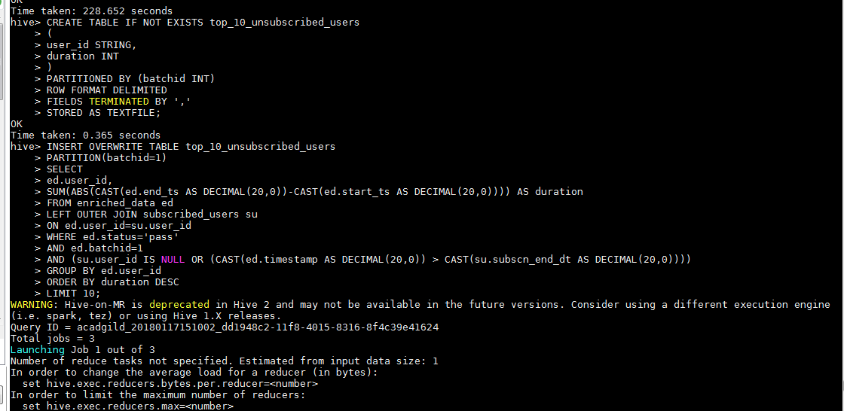

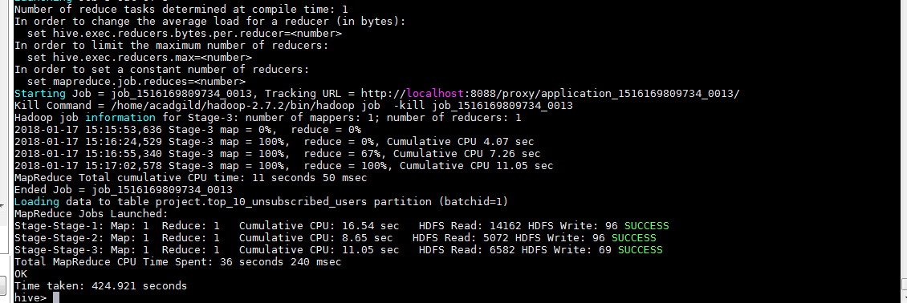

Scheduling:

-----------

We'll be using crontab for job scheduling.

Job has to run every 3 hours

sudo crontab -e

(Press i to enter insert mode)

* */3 * * * /home/acadgild/project/scripts/wrapper.sh

(Press Esc and then type :wq! and press Enter)